How to setup Tenda D152 Bridge mode
Product line: ADSL Model number: D152
This article will guide you how to setup Tenda D152 Bridge mode and the steps as below.
Note: If you have no idea about what is the internet connection type, VPI/VCI value, the accounts (user name and password) please call your ISP for them.
Part 1: Connect the devices
Part 2: Configure your computer
Part 3: Setup the router
Part 4: Check whether you can access internet
Connect the DSL line with the DSL port of D152, and then connect your computer with one of the LAN ports by a cable.
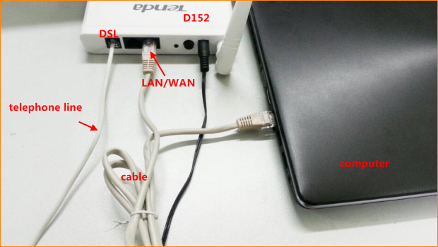
Note: after connection the SYS light should be blinking, the WLAN light should be on or blinking, the DSL light should be on or blinking, the LAN/WAN light should be on or blinking.
1 Click on Network Connection Icon on the system bar, then click on Open Network and Sharing Center.
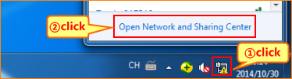
2 Click on Change adapter settings.
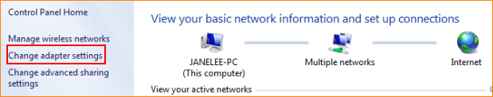
3 Right click on Local Area Connection, then choose the Properties option.
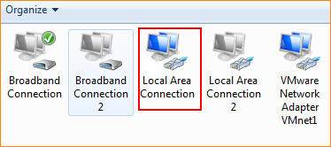
4 Double click on Internet Protocol Version 4(TCP/IPv4)4.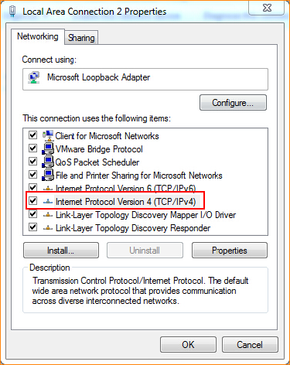
5 Choose Use the following IP address and Obtain DNS server address automatically and then click OK.( The D152 default settings close DHCP in Bridging mode ,so we setup IP address for computer.)
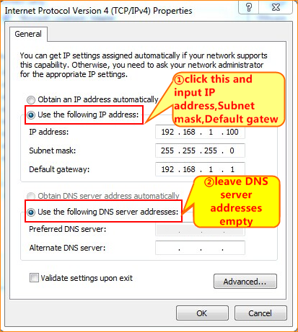
6 Also click on OK on the first Local Connection Properties window.
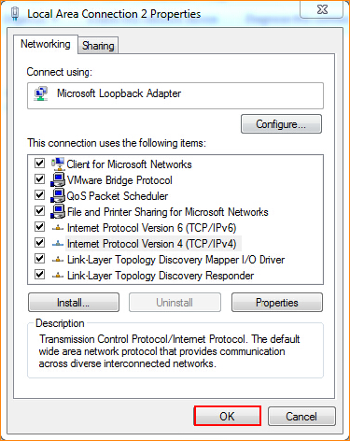
3.1 Setup the router in home page
3.1.1 Open a browser then type 192.168.1.1 in the Address bar, click on Enter.
3.1.2 Type the Username and Password as admin in the bars then click on Login to login the setting page of the router.
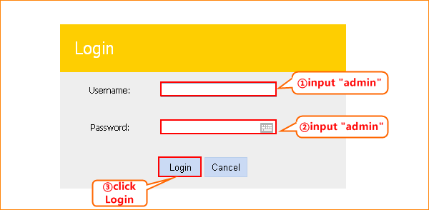
3.1.3 choose ADSL，Country and ISP. The connection type is BRIDGE. You can also change the SSID and wireless key, and then click OK.
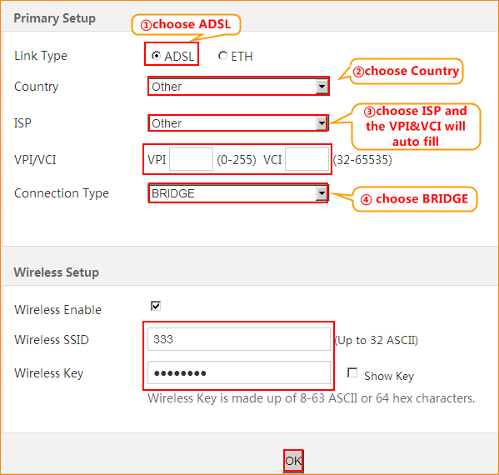
3.1.4 Click on Advanced on the right of the page to login the advanced setting page.
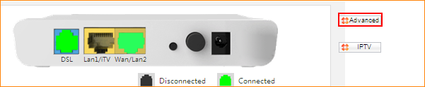
3.1.5 Click on Management and Reboot then hit on the Reboot button to reboot the router for refreshing the device info.
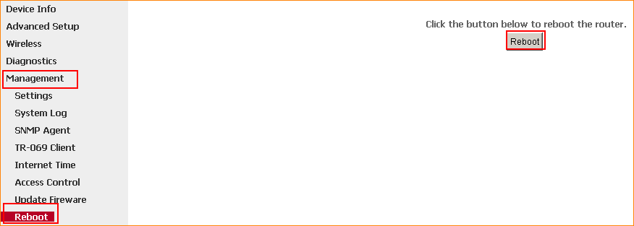
3.1.6 After reboot, Click on Device Info, WAN, then check the WAN Status if the Connection Status shows Connected that means you can access internet, please check.
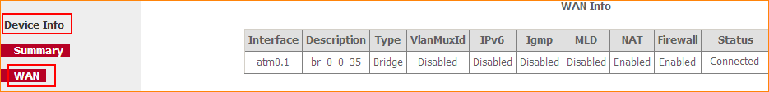
If you can’t, please click here and follow the steps below.
3.2 Setup the router in advanced settings page
3.2.1 Click on Management and Settings, Restore Default then hit on the Restore Default Settings button.
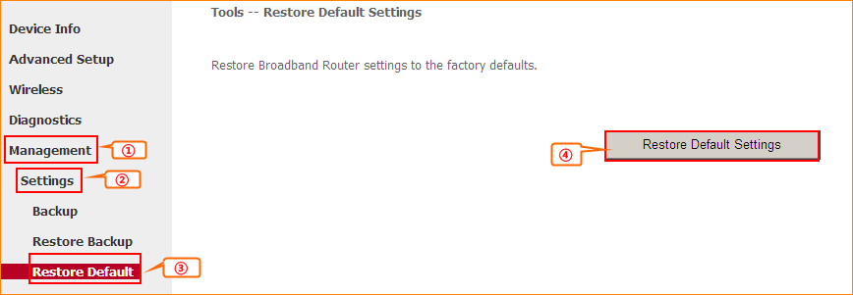
3.2.2 Click on Advanced Setup, Layer2 Interface, ATM Interface and Add. And input VPI&VCI that ISP provides for you, choose EoA, keep other default settings, click Apply/Save. Then you can see ATM Interface exists.
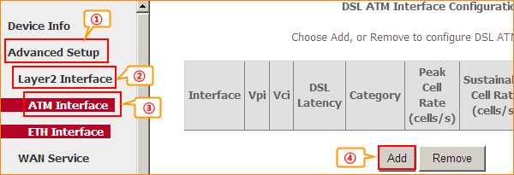
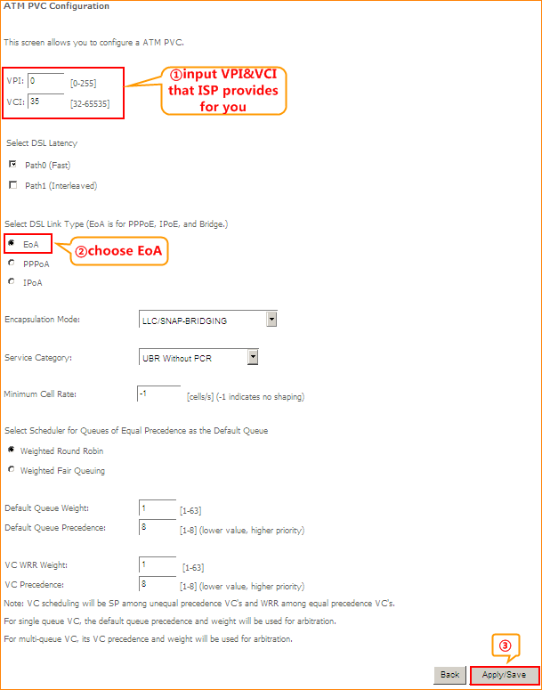
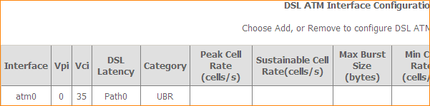
3.2.3 Click WAN Service and Add, keep the atm0 and click Next, then choose Bridging and click Next, and click Apply/Save.
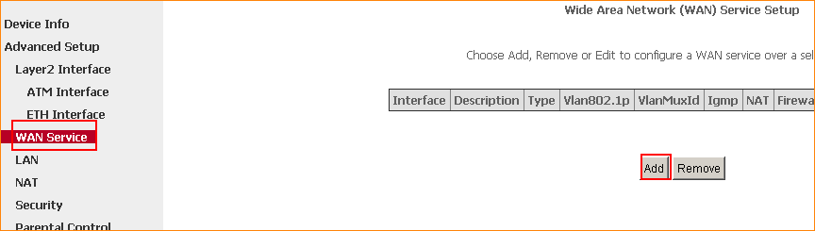
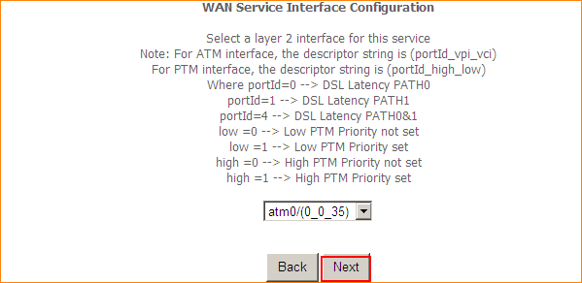
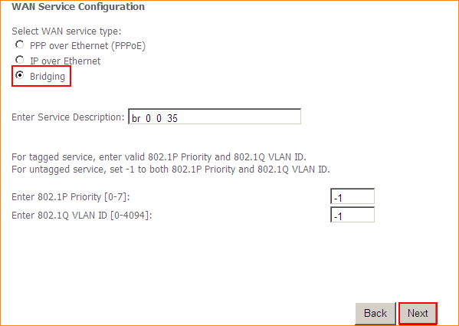
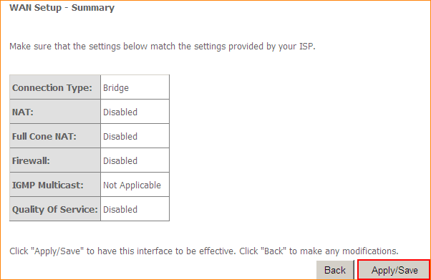
6 Click on Management and Reboot then hit on the Reboot button to reboot the router for refreshing the device info.
1 Click on Advanced to login the advanced setting page, then check the WAN Status if the Connection Status shows Connected that means you can setup your computer and access internet, please check.
2 Click on Network Connection Icon on the system bar, then click on Open Network and Sharing Center.
3 Click on Set up a new connection or network.
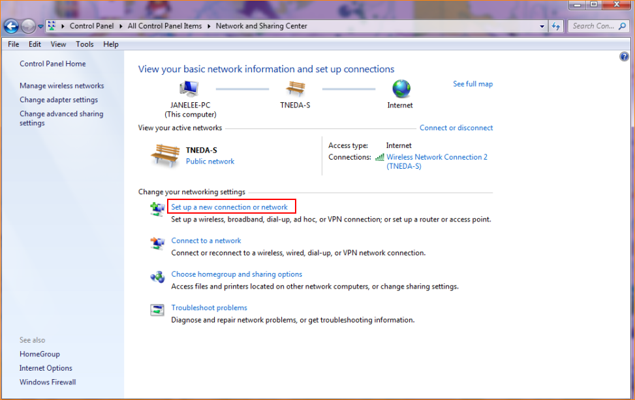
4 Click on Connect to the Internet and Next.
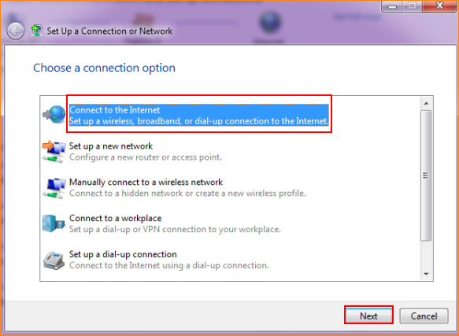
5 Set up a connection
5.1 If you are already connected to the Internet and do not want to set a new one, click Browse the Internet now. (If you do not have connection or want to set up a new one, please click here.)
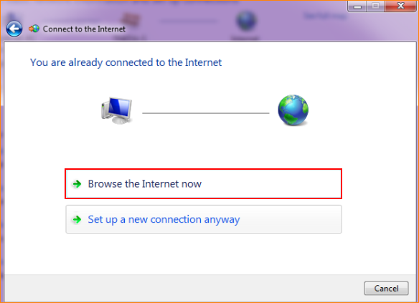
5.1.1 Click Yes and choose the exist connection you want to use and click Next.
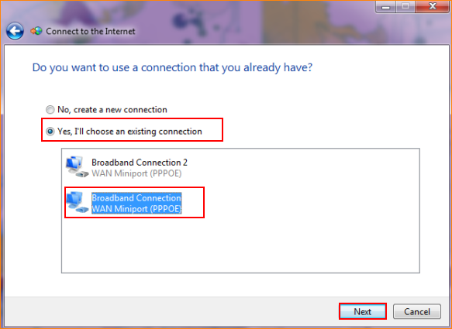
5.1.2 Input user name and password that ISP provides for you. Click Connect.
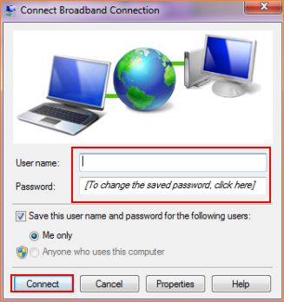
5.2 If you do not have connection or want to set up a new one, please click set up a new connection.
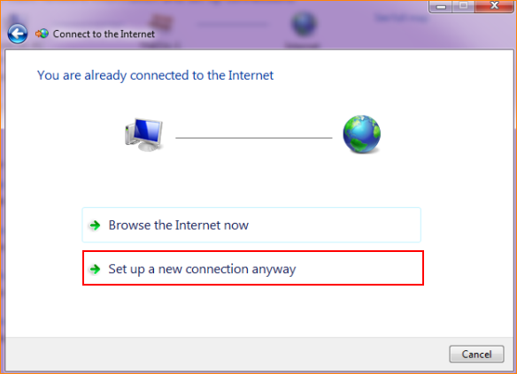
5.2.1 Choose No and click Next.
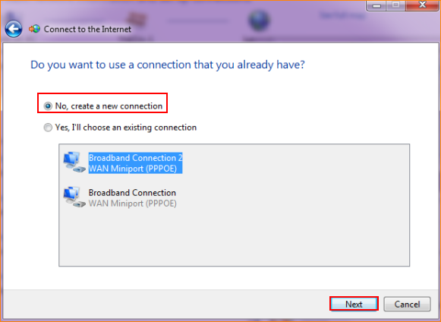
5.2.2 Choose Broadband(PPPoE).
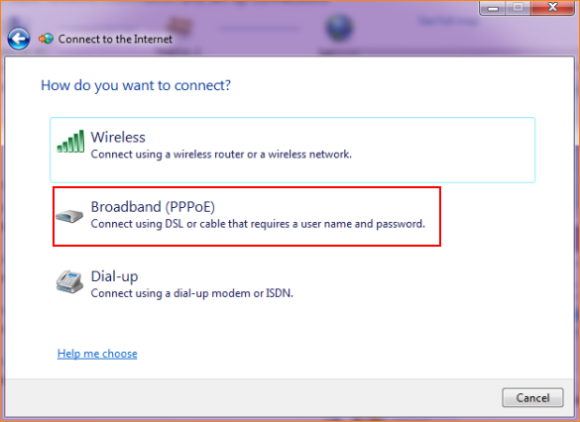
5.2.3 Input user name and password that ISP provides for you. Click Connect.
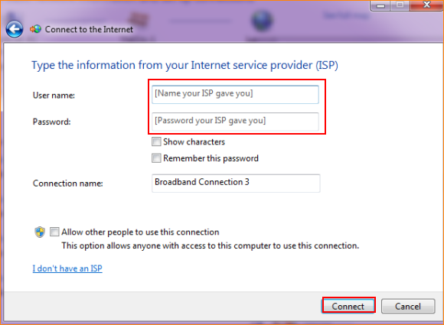
5.2.4 You can check the connection.
